Natchez and Tunica Nations

Text excerpt from Nations of the Southeast by Bobbie Kalman

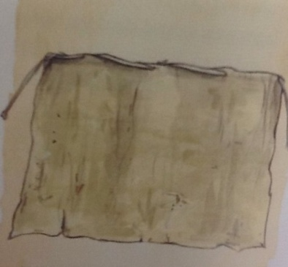The Natchez and the Tunica lived in territories in the western part of the Southeast region. These two nations were made up of thousands of people.

**The Natchez**

The Natchez were one of the largest and most powerful nations in the Southeast region. The nation had between 4,000 and 4,500 members, who lived in more than nine villages. Their territory was along the banks of the lower Mississippi River in present-day Mississippi. The ways of the life of the Natchez were similar to the ways of life of the people who lived during the Mississippian period. The Natchez preserved the Mississippian ways of life longer than their neighboring nations did.

*Natchez women made clothing, including the skirt shown above, by pounding the inner bark of mulberry trees. They also used plant materials to make baskets and fishing nets.*

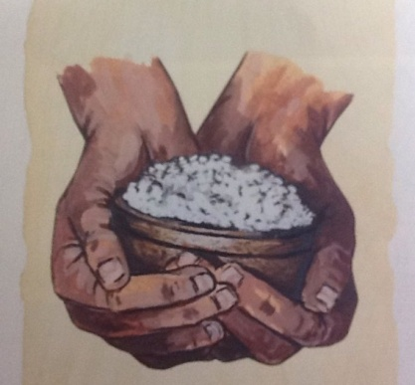 **The Tunica**

The Tunica nation lived in the northwestern part of the present-day Mississippi and in the eastern parts of the present-day Arkansas and Louisiana. Many Tunica villages were located near the Mississippi River on the Mississippi **flood plain**. A flood plain is an area around a river that floods often. Flooding produces **fertile** soil. Fertile soil is rich in nutrients. It is good for growing corn, beans, squash, and other crops. In the late 1600’s, about 2,000 Tunica people lived in these areas. They spoke a language that was also called, “Tunica”. The language belonged to the Tunican language family.

*The Tunica collected water from saltwater springs and then heated the water until the salt could be removed. They used salt to add flavor to foods. They also traded salt to other nations.*

According to the passage, where was the Natchez territory?

A present-day Arkansas

B Louisiana

C the Mississippi flood plain

D lower Mississippi river

Why are the words **flood plain** and **fertile** written in bold print?

A so the reader will read them with excitement

B to show that they are important vocabulary words

C to give the definition of the words

D to make them stand out more than the rest of the text

The Tunica used salt to trade and to-

A make food taste better

B decorate cloth

C heat

D make baskets

Why did Natchez women make clothes out of plant materials instead of cloth?

A towns were too far away to go shopping

B cloth was too expensive

C they used the materials they could easily find

D they had fertile soil good for growing plants

Which word could be used to describe both the Natchez and the Tunica people?

A resourceful

B lazy

C athletic

D friendly

1. How did the Natchez women make their clothing? If you could travel back in time, which modern day invention would you give to these women to help them make clothing? Be sure to give a reason for your answer.

_____________________________________________________________________________

______________________________________________________________________________

______________________________________________________________________________

______________________________________________________________________________

1. List 4 facts about the Natchez nation. Support your answers from the text.

_____________________________________________________________________________

_____________________________________________________________________________

_____________________________________________________________________________

_____________________________________________________________________________

1. In what way did the Tunica nation use saltwater? What step needed to be taken in order to use the salt?

__________________________________________________________________________________

__________________________________________________________________________________

__________________________________________________________________________________

__________________________________________________________________________________

1. The text says that the Tunica Nation lived near a **flood plain**. What is a **flood plain** and describe how this helped the Tunica Nation.

__________________________________________________________________________________

_________________________________________________________________________________

_________________________________________________________________________________

_________________________________________________________________________________

__________________________________________________________________________________

1. Compare how each nation used natural resources to help with daily living. If you lived in the time of the Natchez and Tunica nations, which group would you want to belong? Support your answer with details from the text.

____________________________________________________________________________________

____________________________________________________________________________________

____________________________________________________________________________________

____________________________________________________________________________________

____________________________________________________________________________________

____________________________________________________________________________________

____________________________________________________________________________________

____________________________________________________________________________________

____________________________________________________________________________________

L Jones 2013